White Balance/Filter Assignment

Use your own camera, or borrow one, for this activity
Brand of Camera
Model of Camera
Compact or DSLR

Find the white balance menu or settings on your camera. Most cameras have the same general exposure modes. The camera may also have additional modes that are specific to that camera. We are interested in seeing how choosing a certain mode makes our subject appear in a photograph. You should take pictures of the same subject using the same location, lighting, and viewpoint.

Procedure:
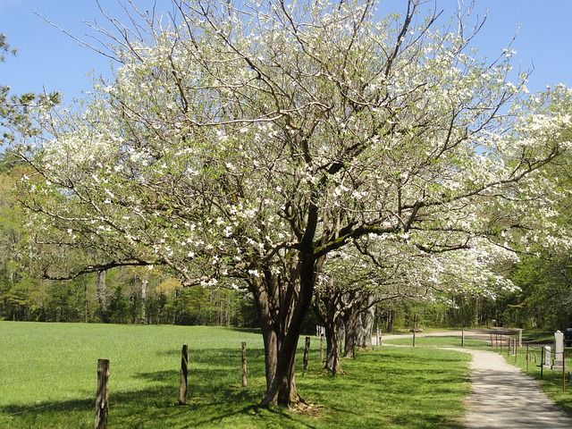
Select the subject: Choose the scene you would like to photograph. We want to be able to photograph the same scene numerous times so it should be a still object/scene. Be creative with your choice! Go outside and find a beautiful tree. Or visit a location at your school, like the gym or art studio. Or simply place a bowl of colorful fruit on the kitchen countertop. Be prepared to make a list of the order that you take the pictures.

WHITE BALANCE PHOTO ASSIGNMENT:
- Take a picture using the Auto White Balance.
- Change the setting to Cloudy and take another picture.
- Change the setting to Daylight and take another picture.
**If your camera doesn’t have these cloudy or daylight settings, choose a setting available and indicate this on the form below**
EXTRA PRACTICE: Continue this process until you’ve moved through all of the white balance settings on your camera.
DIY FILTER ASSIGNMENT:
- Make a homemade filter and place it in front of your camera.
- Take the shot of the same image as in the White Balance Assignment. You can use sunglasses, cellophane wrap, colored cellophane wrap, glass of water, etc.
- Be creative!
Upload the pictures to your computer and insert each of the pictures into the appropriate place on the handout. You may need to adjust the size of the picture to make it fit within our frame.

Automatic | DIY filter:
(Insert the picture taken in automatic white balance mode) | (Insert the picture taken using the DIY filter)
Cloudy
(Insert the picture here…)

Daylight | List the materials you used for your DIY (homemade filter).
(Insert the picture here…)

Additional Mode from camera: ______________
(Insert the picture here…)

Additional Mode from camera: ______________
(Insert the picture here…)

Additional Mode from camera: ______________
(Insert the picture here…)

Reflection:

1. What did you learn from this assignment?

2. Is there a particular mode that you prefer?

3. What would happen to your pictures if one element, such as lighting, was changed?

