- Sign in: http://students.weebly.com
Username and password will be provided by teacher.

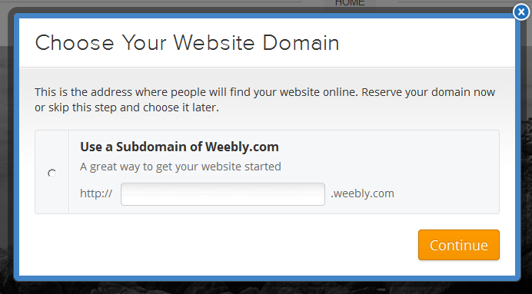
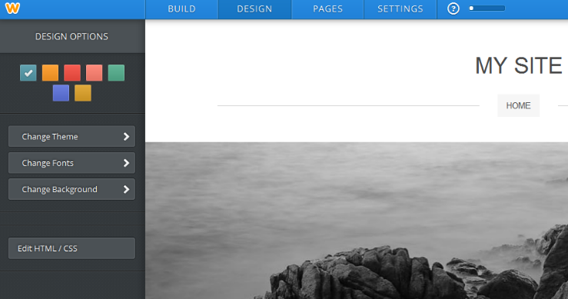
- Give your site a name (subdomain)
**This should describe your site
**Be Creative
**If name is taken, choose a different name

3. Click “Design”
4. Change Theme

- Click the “Design” Button
- Change Theme, Fonts, Background, Colors as you desire.

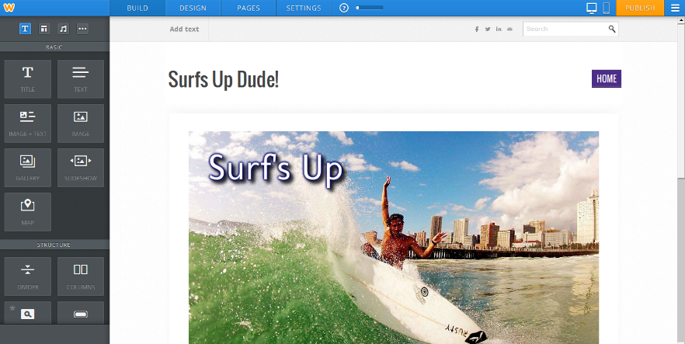
- Design your home page by adding/changing graphics.
Add elements from left side. Use columns and dividers.

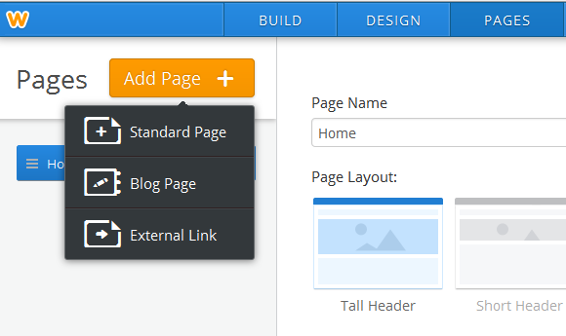
- After you design your home page. Begin adding other pages to your site.
1) Click on Pages at the top…
2) Click Add Page +…
3) Select type of page…Choose Standard.

- Begin designing the second page.
- Add and design additional pages (follow instructions) for Weebly Webpage Project.

