Basic Parts of a Computer—Lesson 5
Watch the video provided and answer the following questions. You will be tested over this information, and you will be required to complete a narrated project.
INTRODUCTION:
- What are the basic parts of the computer?
_____________________
_____________________
_____________________
_____________________
_____________________
Watch video on website
COMPUTER CASE:
- What is the computer case?
- What does the computer case contain? ________________________, ______________________, and ________________.
- What are the two main types of computer cases? ________________ and _______________.
- What is an All-in-one computer?
MONITOR:
- The monitor works with a ___________ __________, located ___________ the computer case, to display _____________ and ____________ on the screen.
- New monitors usually have _______ (liquid crystal display) or LED (light-emitting displays). These can be made very thin, and they are often called _______________________.
- Older monitors use __________ (cathode ray tube—similar to old television tubes) displays. CRT monitors are much _______________ and ______________, and they take up more desk space.
KEYBOARD:
- The _______________ is one of the primary ways we communicate with the computer and enter data.
- Keyboards come in different shapes and sizes such as _____________________ and __________________.
- Look online and define the term ergonomic. _____________________________________________
_____________________________________________________________________________________.
- Research images of keyboards and know the difference between a standard keyboard and an ergonomic keyboard.

MOUSE:
- The mouse is an __________________ for _______________ with computers. Commonly known as a ___________________________. It lets you _____________ to objects on the screen, ___________ on them, and ____________ move them.
- What are the two main categories of mice? ______________________ and _________________.
- Define Optical Mouse:
- Define mechanical Mouse:
- You can thank me…but you do not have to do the mouse tutorial in the middle of page four. (if you want to, click on the link provided).
MOUSE ALTERNATIVES:
- Define Trackball:
- Define Touchpad:
- What are the two reasons someone would prefer to use the trackball or touchpad?
  - Many people find them _______________
  - They also require ____________________
POWER CORD:
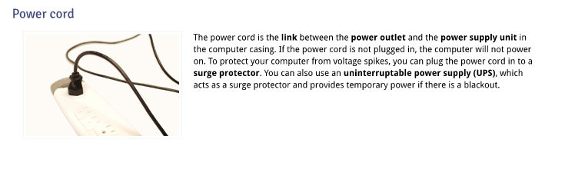
- The power cord is the _________ between the _________________________ and the ____________________________ in the computer casing. To protect your computer from voltage spikes, you can plug the cord into a _____________ _________________. You can also use an ___________________________ ________________ _______________ (UPS), which acts as a surge protector and also provides temporary _____________ if there is a blackout.
Looking at the classroom computer in front of you, circle the correct type of case and devices listed below.
- Computer case: tower or desktop
- Keyboard: standard/enhanced, ergonomic, or wireless
- Monitor: LCD, CRT, or Gas Plasma
- Mouse: Optical or Mechanical

