Audacity Animal Poem Project (Voiceover/sFx)
1. Visit Ken Nesbitt’s poetry page for kids. You will locate a poem that you will narrate and add sound effects for.
- http://www.poetry4kids.com/cat-Animal.html
Your voice must sound “animated/in character” during the narration. No audio sound effect is allowed during your speaking part other than an echo or fade (no pitch or speed adjustments).

2. Locate one (1) instrumental song and eight (8) sound effects that will enhance your poem project.
Sound effects are required throughout the poem. And, a light musical instrumental should be in the background (keep the music turned down enough so that the poem can be heard clearly).
List of Sites for Free Music and Sounds:
OrangeFreeSounds
Free Music Archive
GRSites (Free Sound Effects)
Jamendo
Free Sound Effects
Media College
OrangeFreeSounds Loops

**You can also search for other sites with instrumental music and sound effects. If you have an account through Google/YouTube, you have access to free audio files.
3. Copy/Paste the poem on the page below. Make notes ON THAT PAGE where you added a sound effect.
See the example document on the last page of this file. Note where you got your sound effects as well at the bottom!! This sheet must be included when you turn in your MP3 file in Edmodo…with YOUR Poem and Audio File info.

RUBRIC:
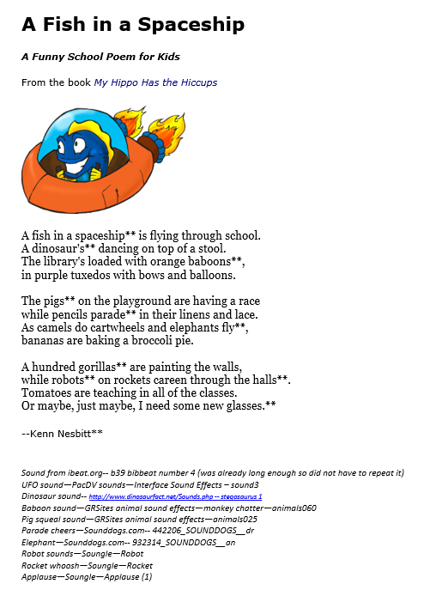
Your finished file must be exported as an MP3 file, scoring guide submit in Edmodo with poem/notes attached, and the MP3 file submitted as well through Edmodo.
Requirement | Points Possible | Deductions
High quality narration with personality/fun and easy to hear and understand | 5
Light musical instrumental throughout (turn down) | 5
Minimum of 8 sound effects added to give the story some “fun” (not too loud, not too quiet) | 10
Printout included with sounds noted and sources given | REQUIRED or no grade
MP3 format submitted through Edmodo…MP3 file, not the Audacity file. | 10
TOTAL | 30

Name:__________________________________
Poem: __________________________________ (attach poem with noted information!)

This is what should be submitted into Edmodo:
1. Final MP3 (Your MP3 should include: dramatized poem (your voice), instrumental track, 8 or more sound effects)
(Put the following on a ONE PAGE DOCUMENT):
2. A pasted copy of your animal poem.
3. Notate in the poem where you added sound effects.
4. Cite the name of the sound effect and the site where you downloaded them.
5. Cite the name of the instrumental track and the site where you downloaded them.

EXAMPLE FOR NOTES PAGE

A Fish in a Spaceship
Your Poem information goes here.
A Funny School Poem for Kids
From the book My Hippo Has the Hiccups
Copy/Paste Your Poem here AND Author)
**Notice the asterisks (**). This indicates where a sound effect has been added.
A fish in a spaceship** is flying through school.
A dinosaur's** dancing on top of a stool.
The library's loaded with orange baboons**,
in purple tuxedos with bows and balloons.
The pigs** on the playground are having a race
while pencils parade** in their linens and lace.
As camels do cartwheels and elephants fly**,
bananas are baking a broccoli pie.
A hundred gorillas** are painting the walls,
while robots** on rockets careen through the halls**.
Tomatoes are teaching in all of the classes.
Or maybe, just maybe, I need some new glasses.**
--Kenn Nesbitt**

- Sound Track: from ibeat.org-- b39 bibbeat number 4 (was already long enough so did not have to repeat it)
- UFO sound—PacDV sounds—Interface Sound Effects – sound3
- Dinosaur sound-- http://www.dinosaurfact.net/Sounds.php -- stegosaurus 1
Notice sound track is cited
Also, there were 9 sound effects added.
- Baboon sound—GRSites animal sound effects—monkey chatter—animals060
- Pig squeal sound—GRSites animal sound effects—animals025
- Parade cheers—Sounddogs.com-- 442206_SOUNDDOGS__dr
- Elephant—Sounddogs.com-- 932314_SOUNDDOGS__an
- Robot sounds—Soungle—Robot
- Rocket whoosh—Soungle—Rocket
- Applause—Soungle—Applause (1)

**Listen to the final product:
http://bristolbhhsmultimedia.weebly.com/uploads/9/0/2/1/9021329/audacity_animal_poem_practice___skinner_example_poem_mp_.mp3

